**Chapter 1**

**Introduction**

**Chapter 2**

**Analysis and Requirement Specification**

**Chapter 3**

**Design**

**Chapter 4**

**Implementation**

**Chapter 5**

**Snapshots**

**5.1 Screen shots:**

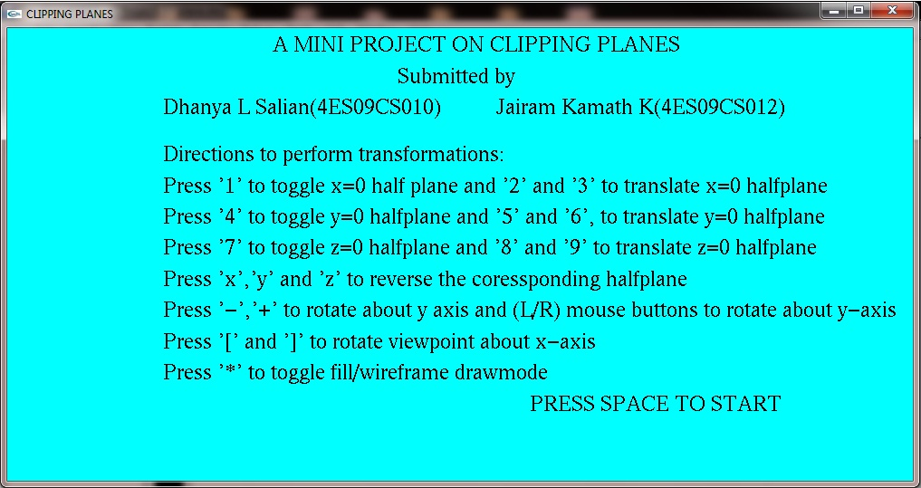

Fig 5.1.1 Screen shot showing front screen

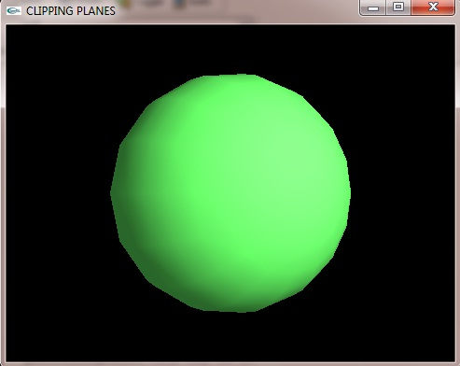

Fig 5.1.2 Screen shot showing clipping plane

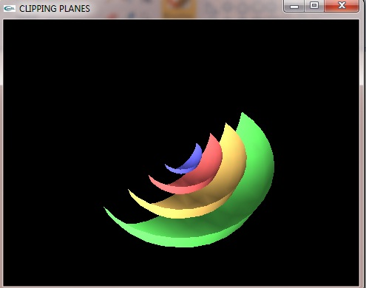

Fig 5.1.3 Screen shot after toggling z=0 halfplane

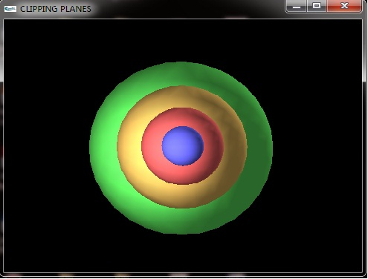

Fig 5.1.4 Screen shot after toggling x=0 halfplane

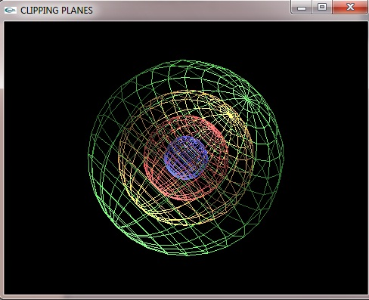

Fig 5.1.5 Screen shot shows wireframe drawmode

**Chapter 6**

**Conclusion**

**REFERENCES**

[1] AAAA

[2] AAAA